* SOAP 🡪 Simple Object Access Protocol which is used in WebService communication.

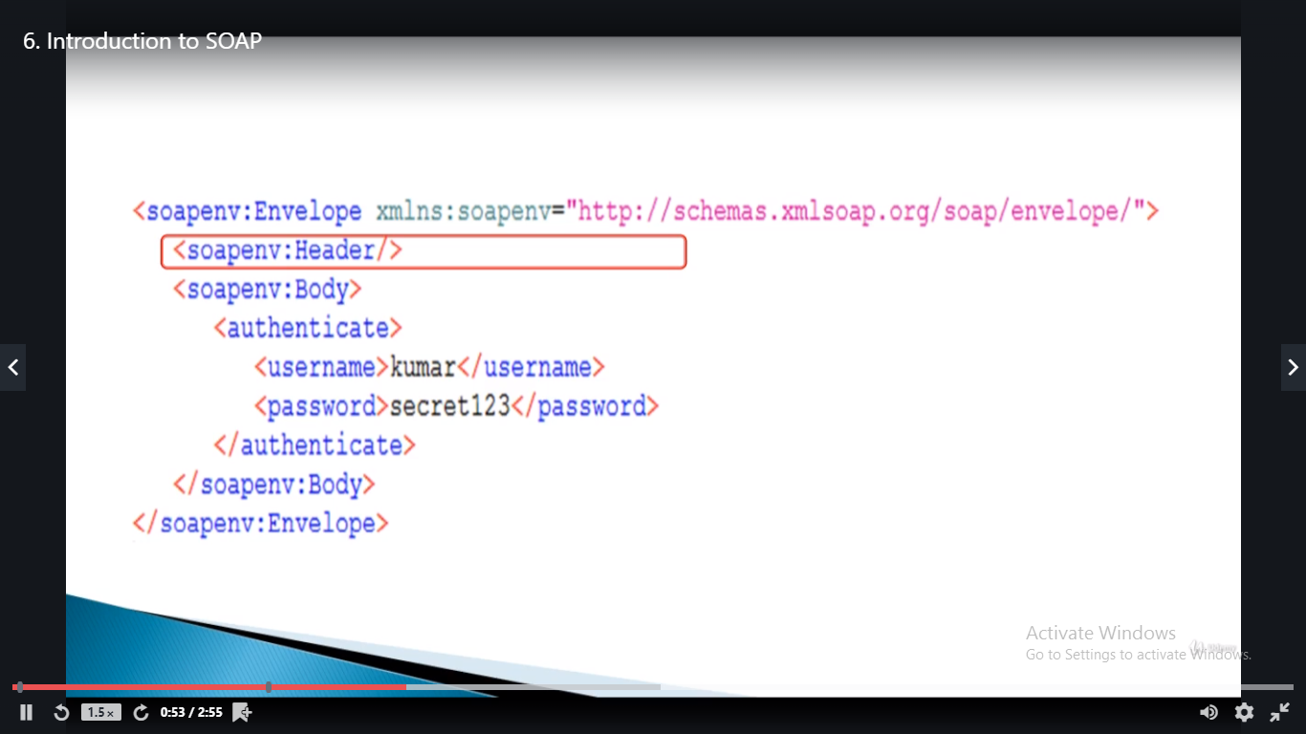

* Below is the operation name.

<Authenticate>

And user name and parameter are passwords.

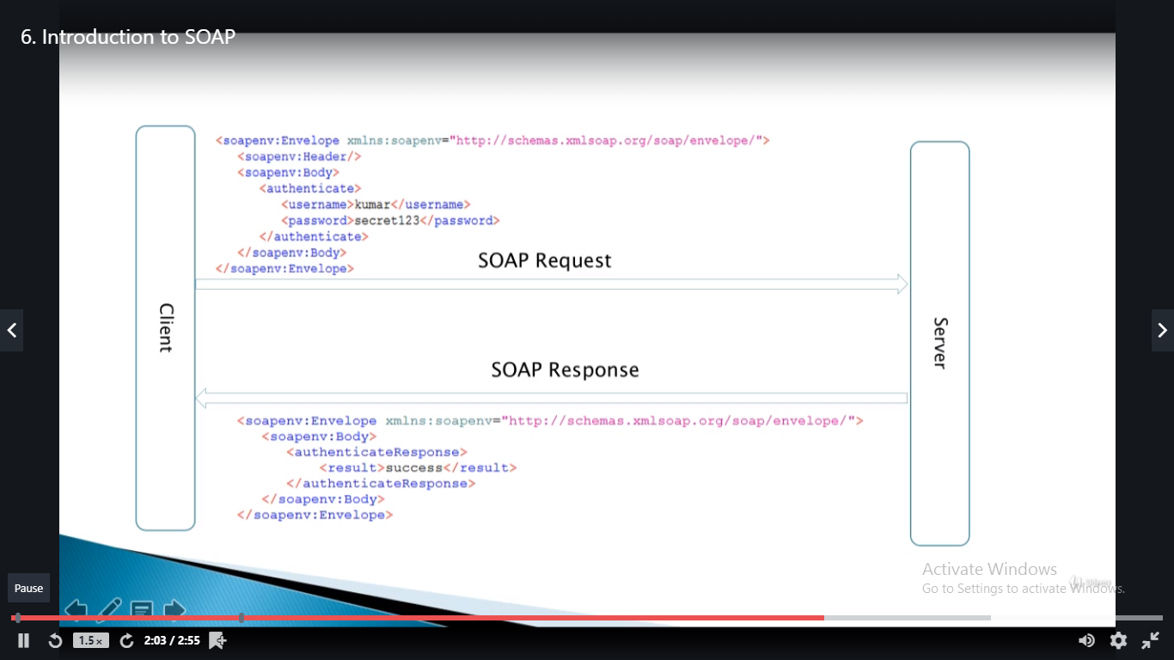

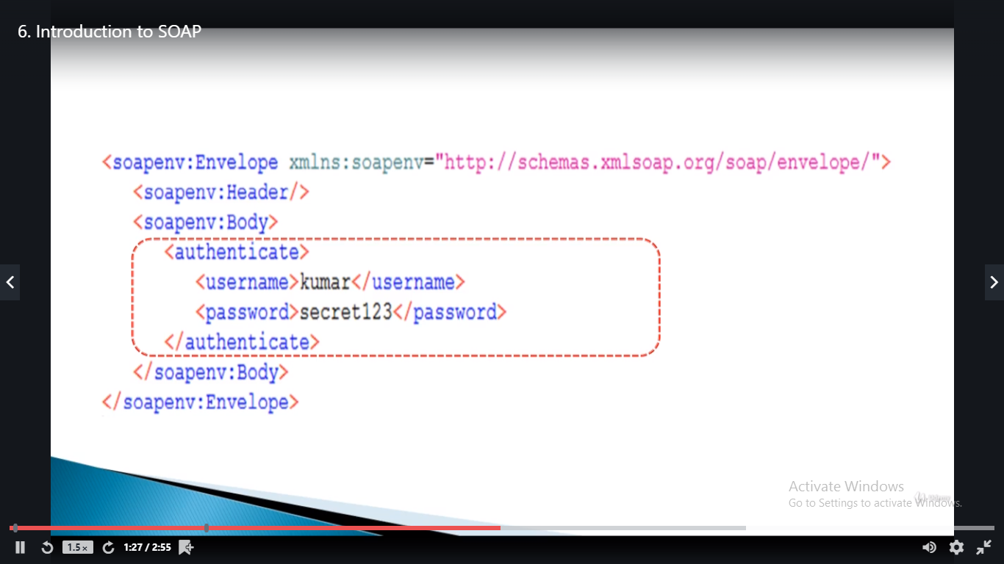

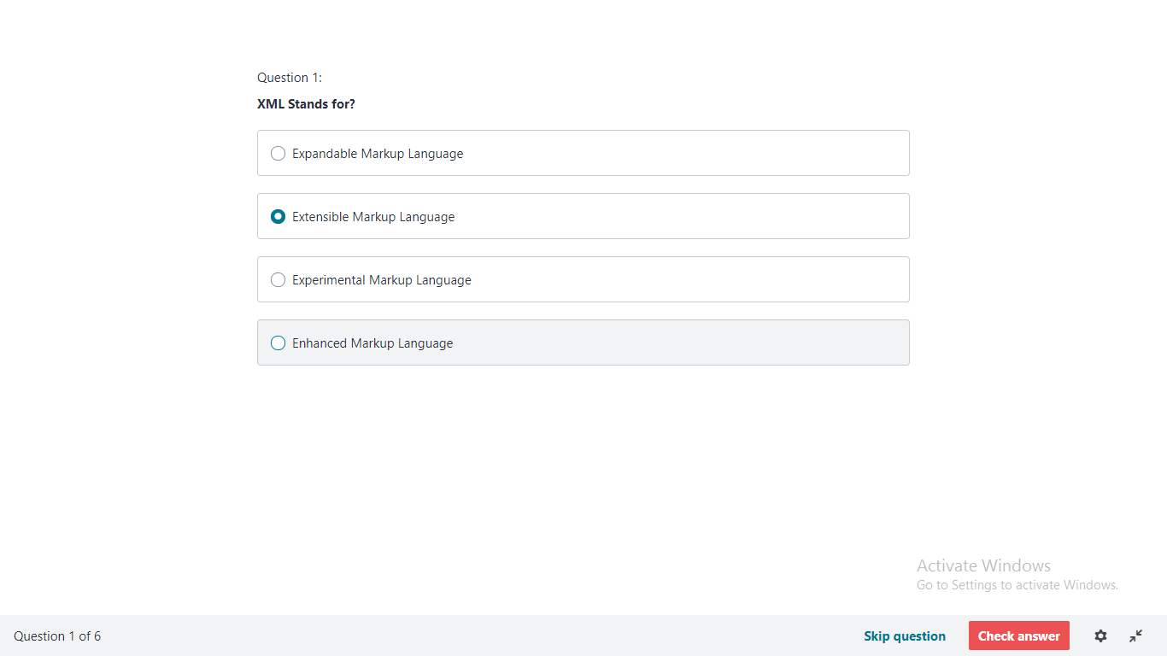

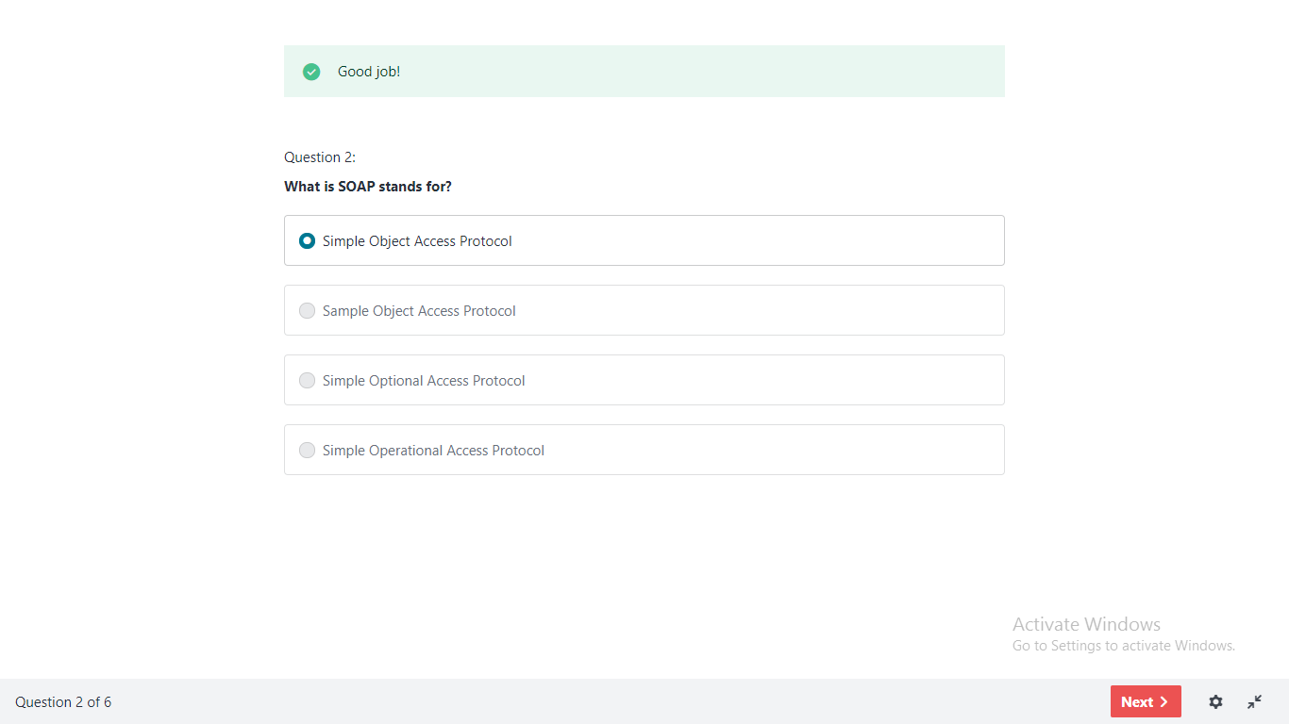

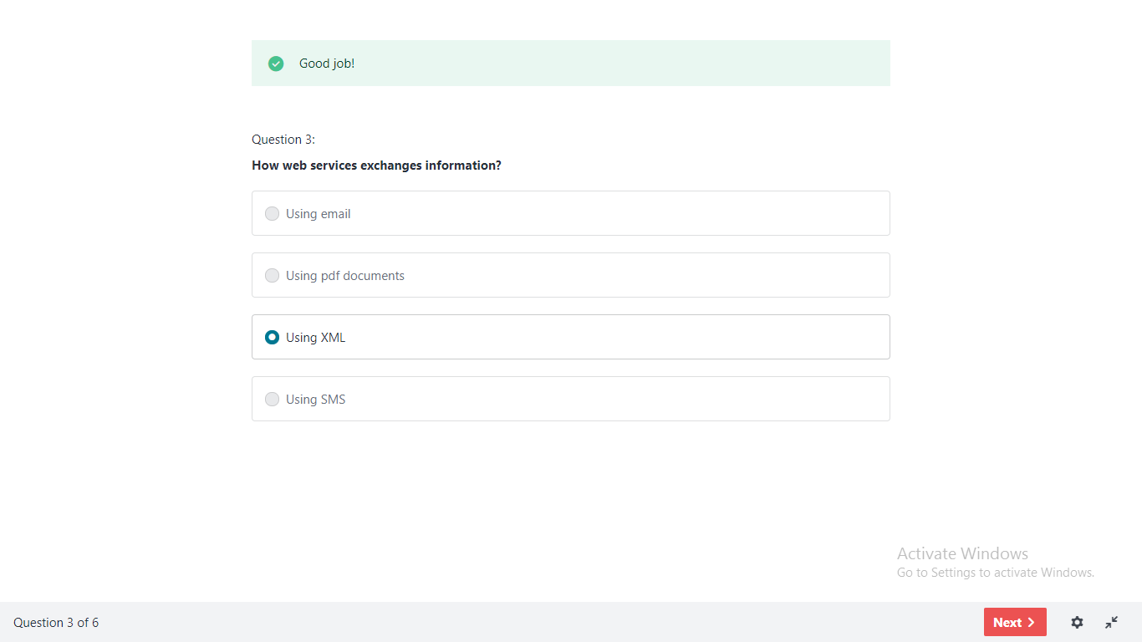

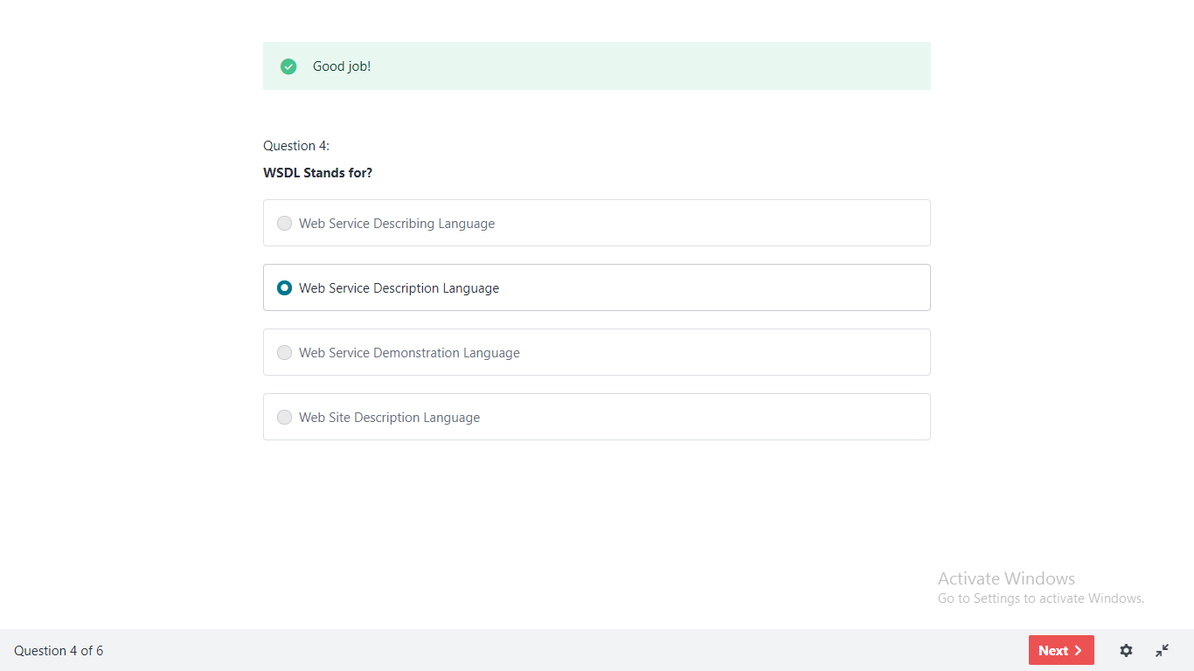

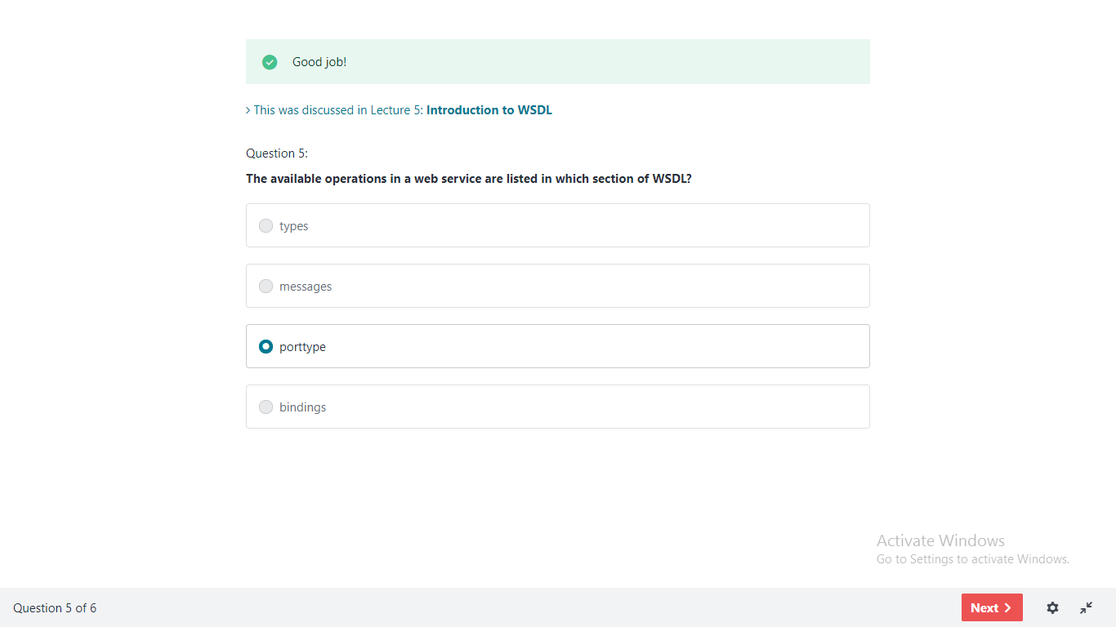

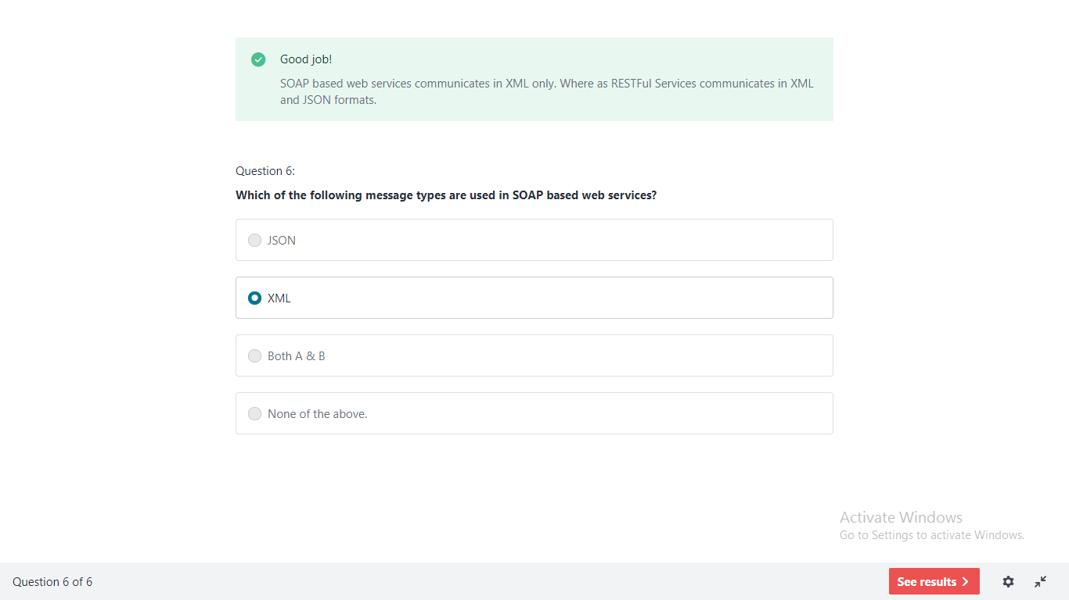

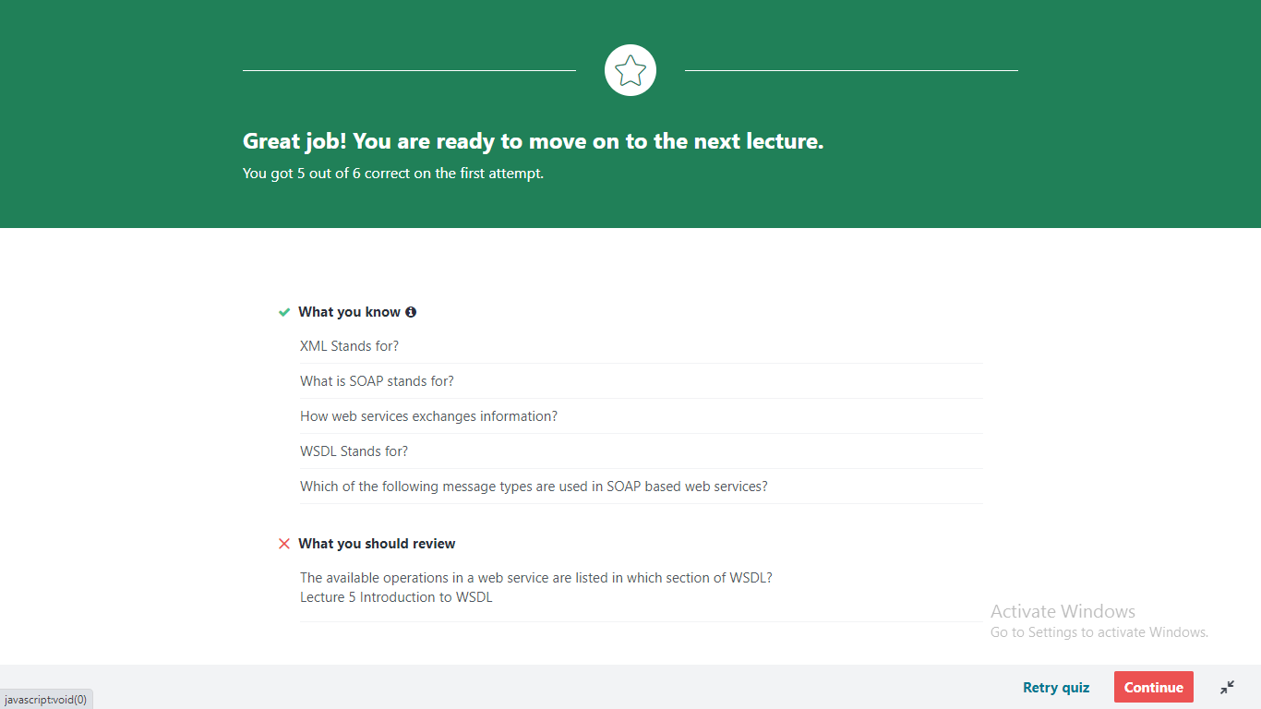

|  |
| --- |
|  |
|  |

|  |
| --- |
|  |

1. **How to run local services?**

First please read the topic 7 under Section 3.

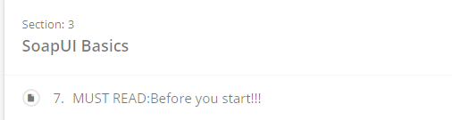

In this section you can see 3 topics.

**Important** : Please read topic 8, where I explained how to run these services.

In topic 9, I have given a jar file "soap-services-1.0.0.jar"

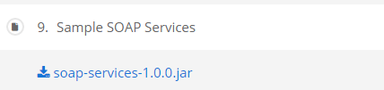

1. Download the jar file in your favorite location e.g. : c:\downloads

2. Open command prompt, go to that directory : cd\ downloads

3. Execute the command

E.g: java -jar soap-services-1.0.0.jar

1. **When I am trying use the WSDL from the course , I am getting 503 error / 404 error.**

Answer: This can be due to the website is not working today. If that is the case you can run local services as mentioned above.

1. **When I am trying to run local services, got following error**

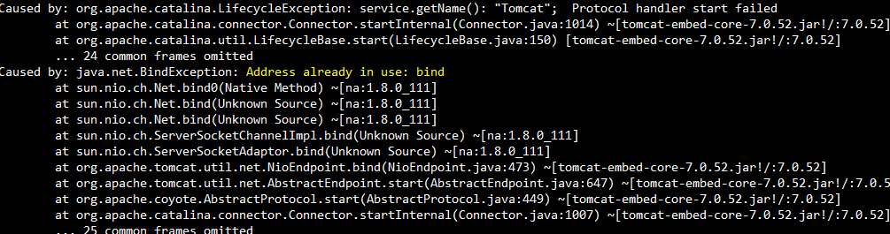

Answer: This can be due to the port "8080" is already in use due to following reasons.

* You are already running mock services on your machine.
  1. Please stop the mock services and try again. If the problem still exists restart SoapUI and try again. But still the problem exists then restart your machine.
* Any other servers (like tomcat) running on your machine. Please stop that server and try again.

1. **Is there any way to change this default port?**

**Yes.**

**Use command : java -jar soapui-services-1.0.0.jar -Dserver.port=9090**

this will start the services on port 9090, you can use any port which is available.

1. **How to get the WSDL file?**

Please check with the developers in the project. Ask them for WSDL URL. If the URL is not available them ask them to give the WSDL file.

1. **BLZ bank service is not reachable / WSDL URL** http://www.thomas-bayer.com/axis2/services/BLZService?wsdl **doesn't work!**

May be the website is down. Please use local services as described in Question 1.

